Day 53

DIY

DIY Questions:

Justin is working on Jenkins. Think of such a situation where he creates a job, adds the GitHub repository to it, and uses Jenkins to execute some tasks. Help Justin in performing the following task.

Tasks:

1. Start Jenkins Dashboard.

2. Create a new job –Freestyle, give it a name as CloneGitRepo

3. Select a git hub repository :https://github.com/edureka-git/edureka.git

4. Add the repository in the freestyle job

5. Also add a custom workspace path as /tmp/workspace on the freestyle dashboard -> General Tab -> Advanced field

6. Build the job and check the files are pulled in the custom workspace

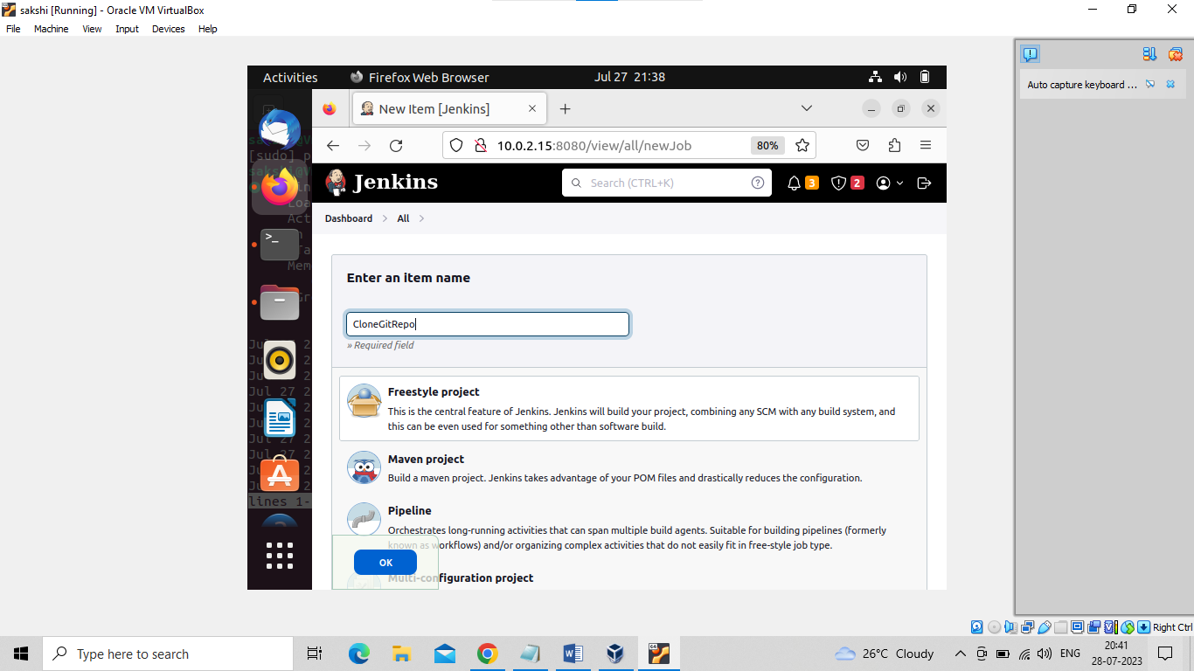

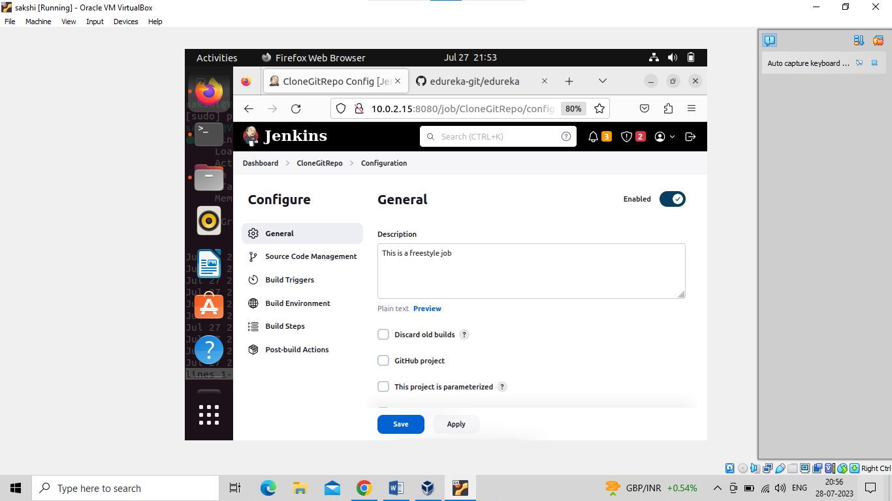

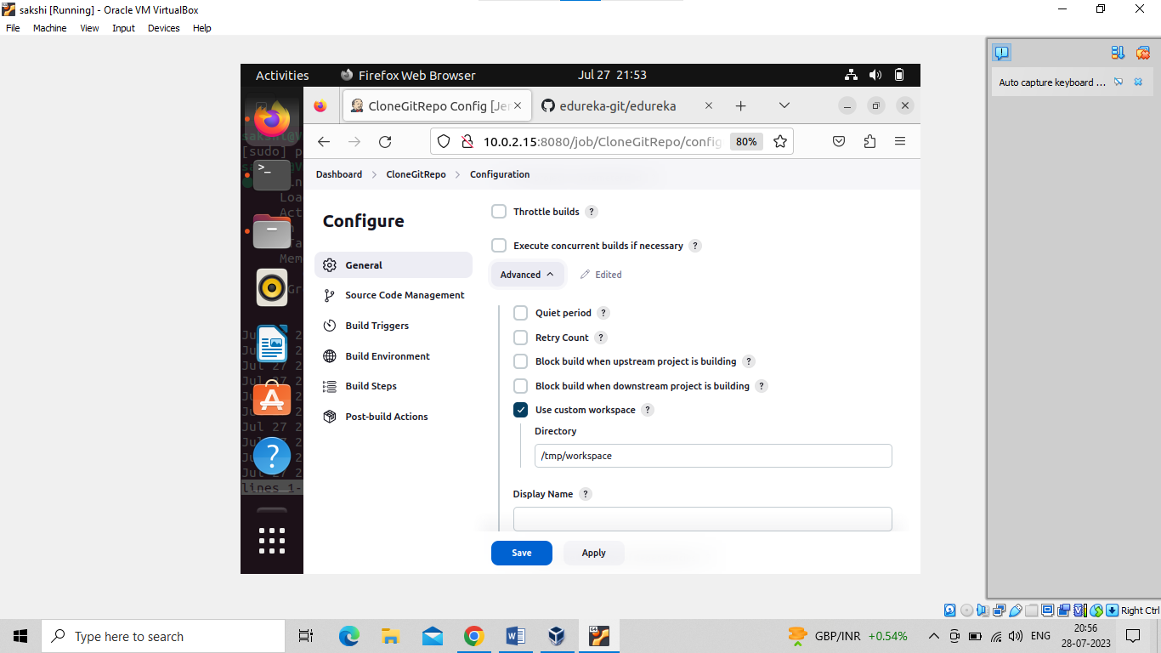

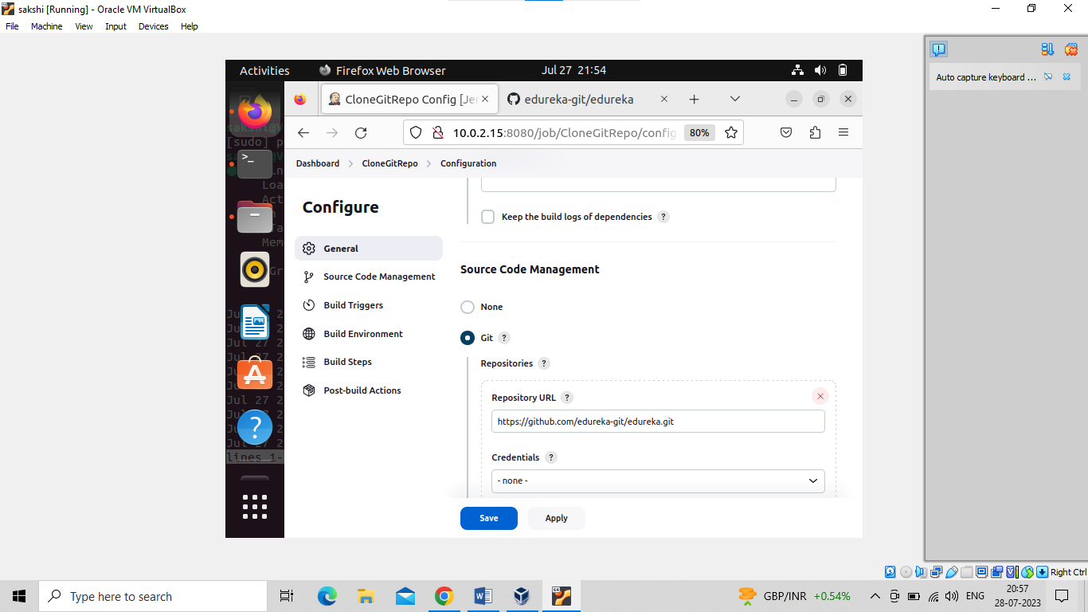

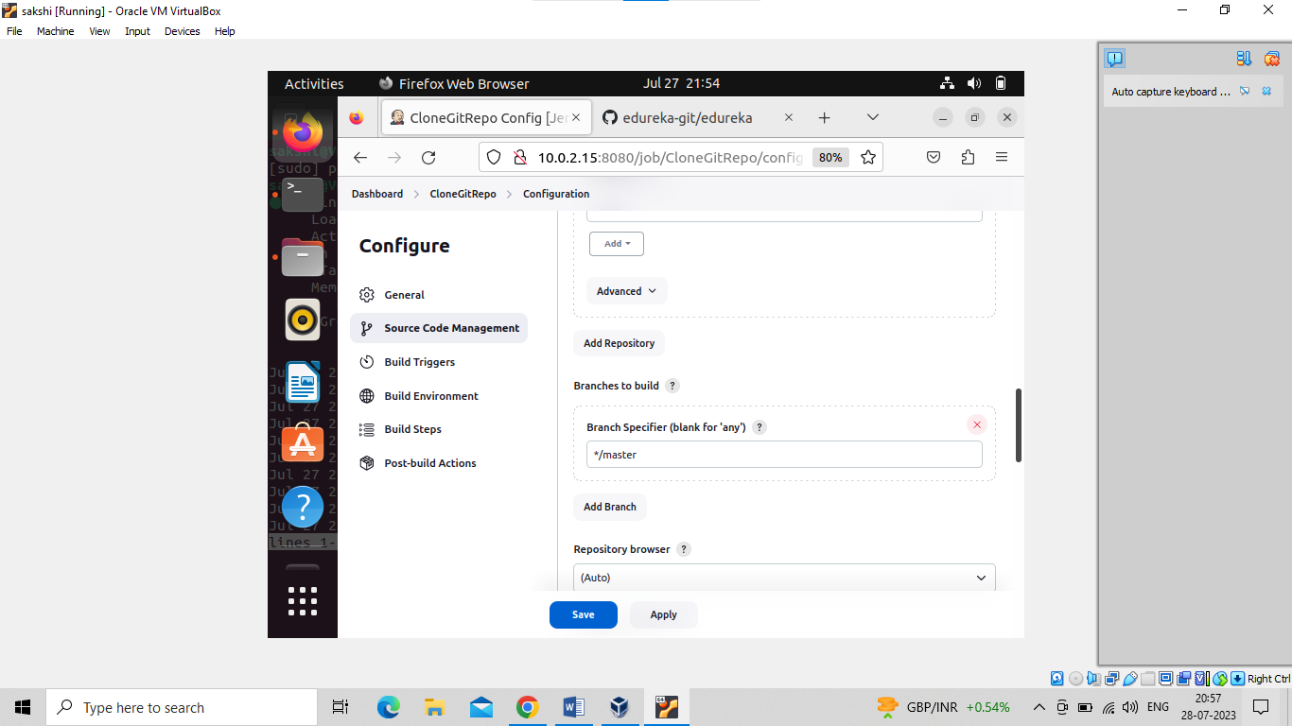

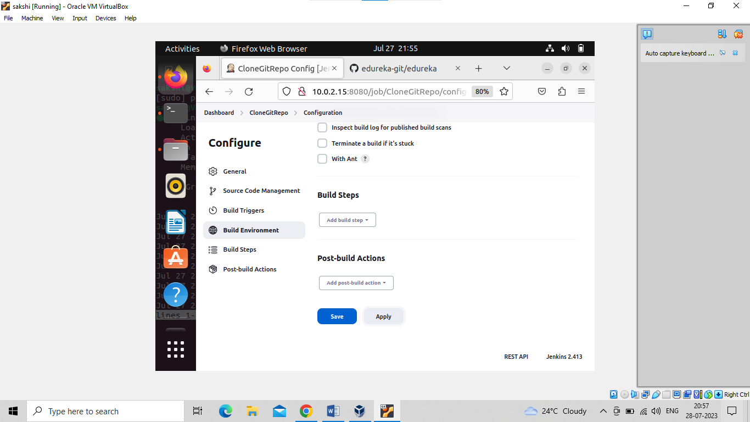

Click on save

